## Faculty of Computing

**Class: BSE-Section A 2025  
Course: Applications of ICT**

# **Lab 03: Programming concepts (Assembly and Python, Git_Github)**

**Date: 29, Sept 2025**

**Student Name:**

**1. Muhammad Ali**

**2. Sajeel Nadeem**

**LMS ID:**

**1. 553575**

**2. 540994**

**Part A: Assembly**

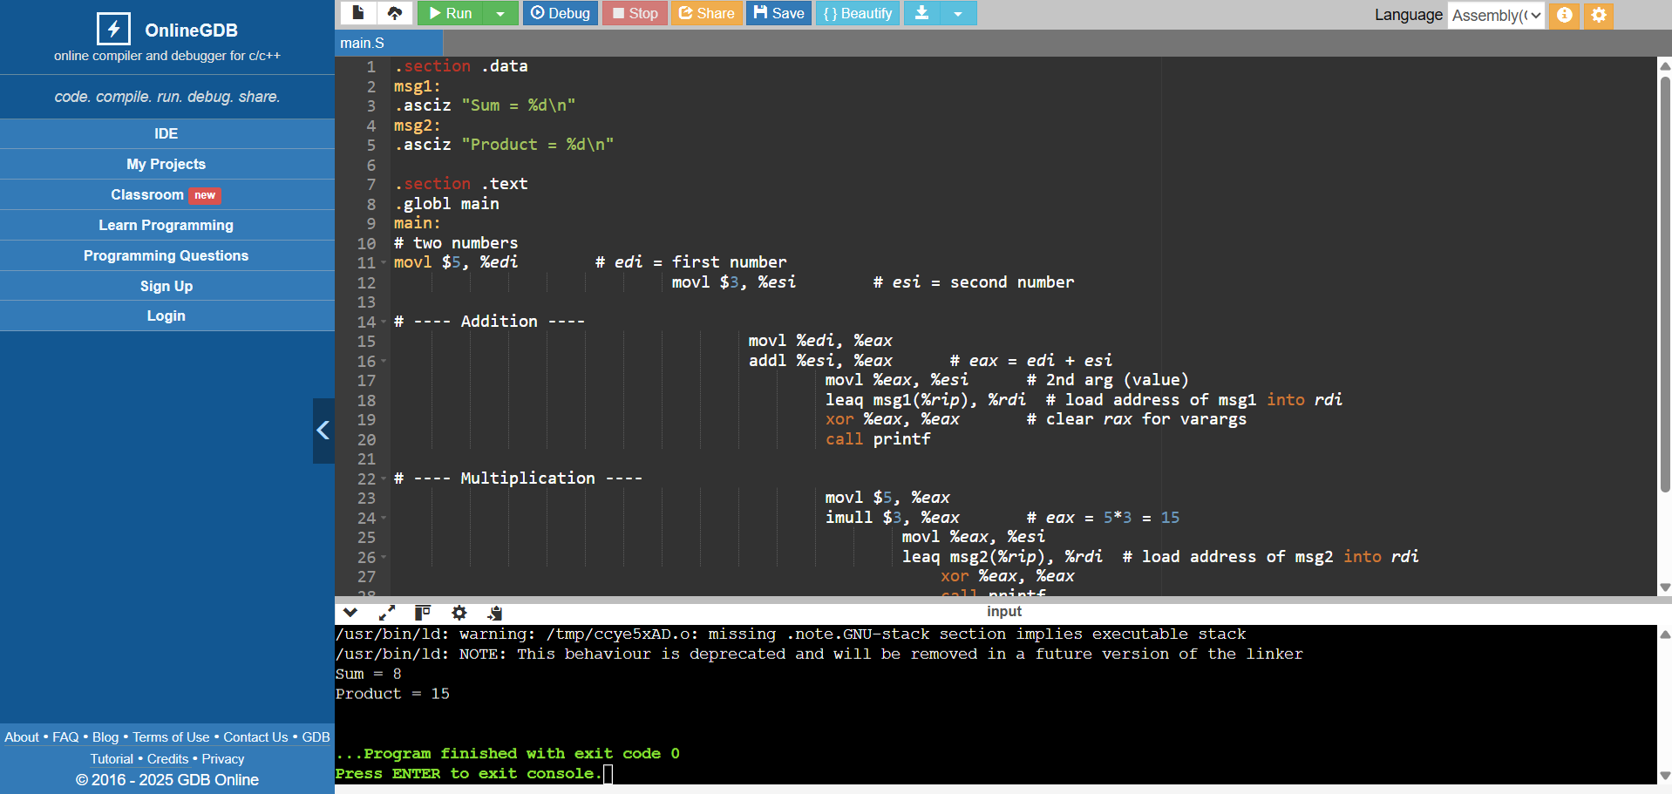

**Part B: Python**

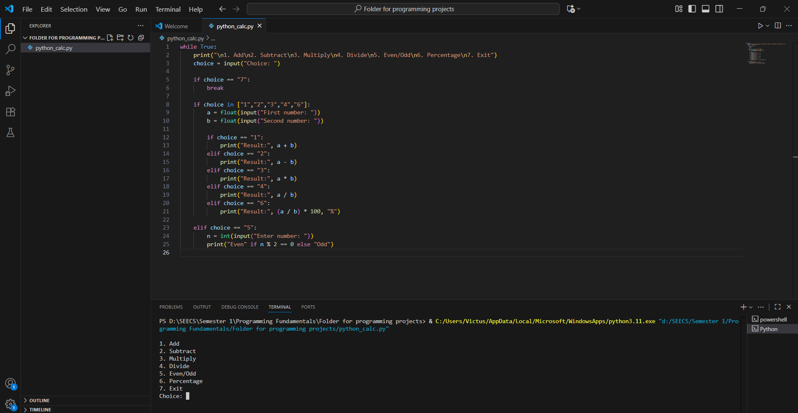

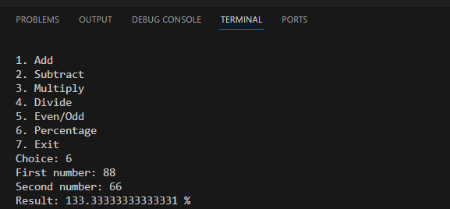

**Part C: Comparison Document (README.md)**

|  |  |  |  |
| --- | --- | --- | --- |
| **Feature** | **Assembly Example** | **Python Example** | **Notes** |
| **Variable storage** | MOV EAX, 5 | x = 5 | Assembly uses registers; Python uses variables in memory. |
| **Printing output** | INT 21h | print() | Assembly relies on system interrupts; Python has built-in functions. |
| **Arithmetic** | ADD AX, BX | x + y | Assembly is step-by-step; Python is more abstract and simple. |